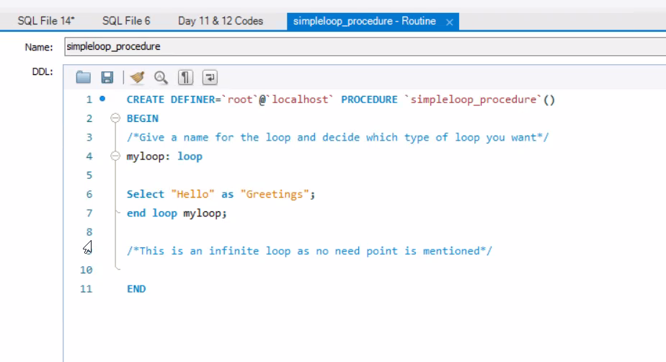

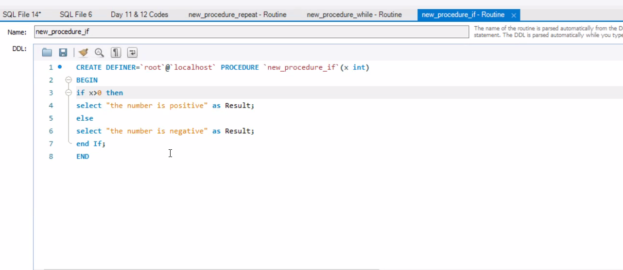

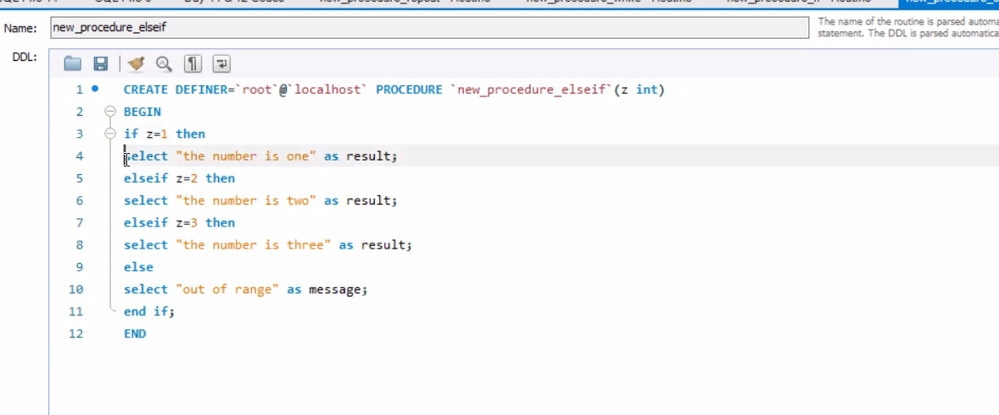

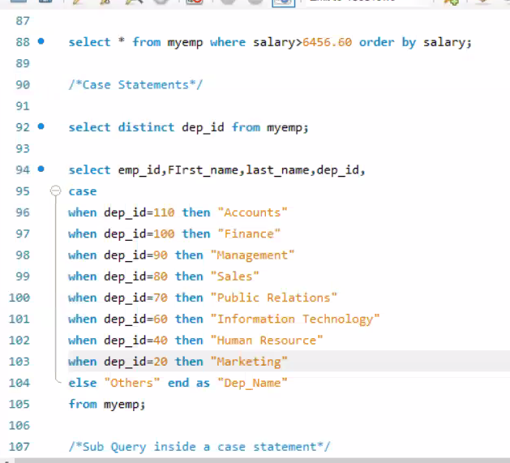

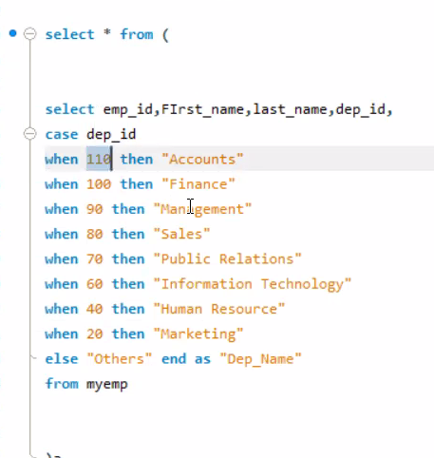

Co

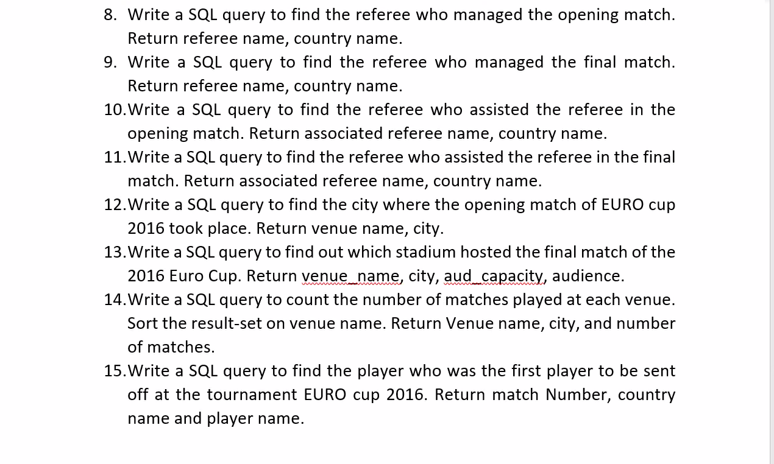

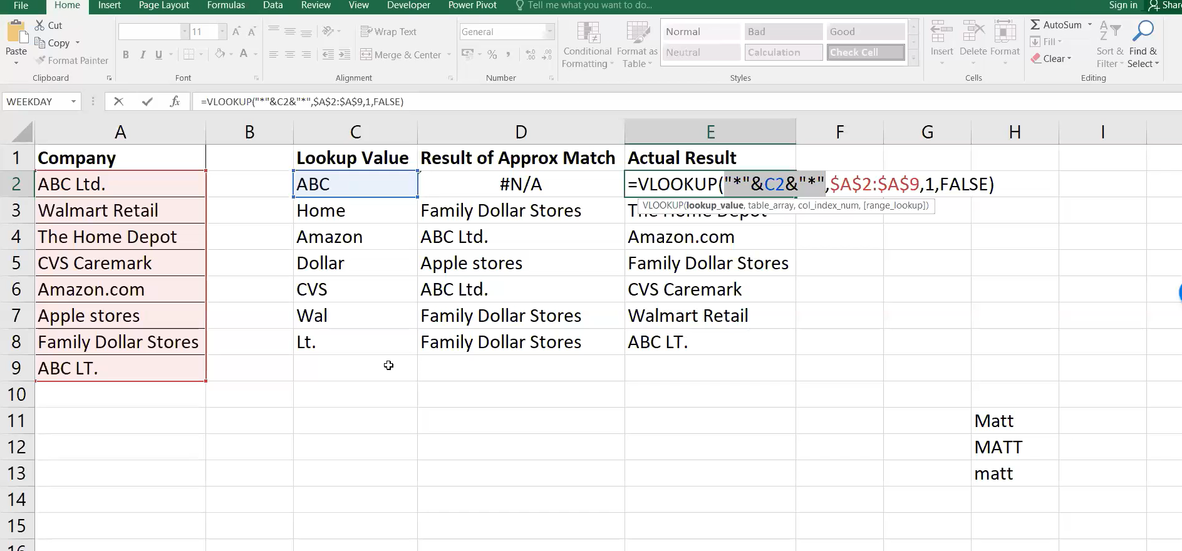

Triger : Table level: User defined object

Views

Stored procedure

Triger

Other are

AICID = Atomicity

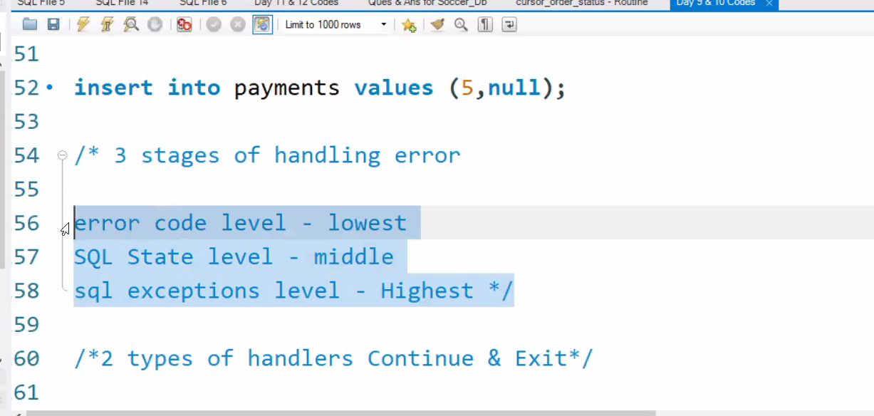

6 Methods of Error handling

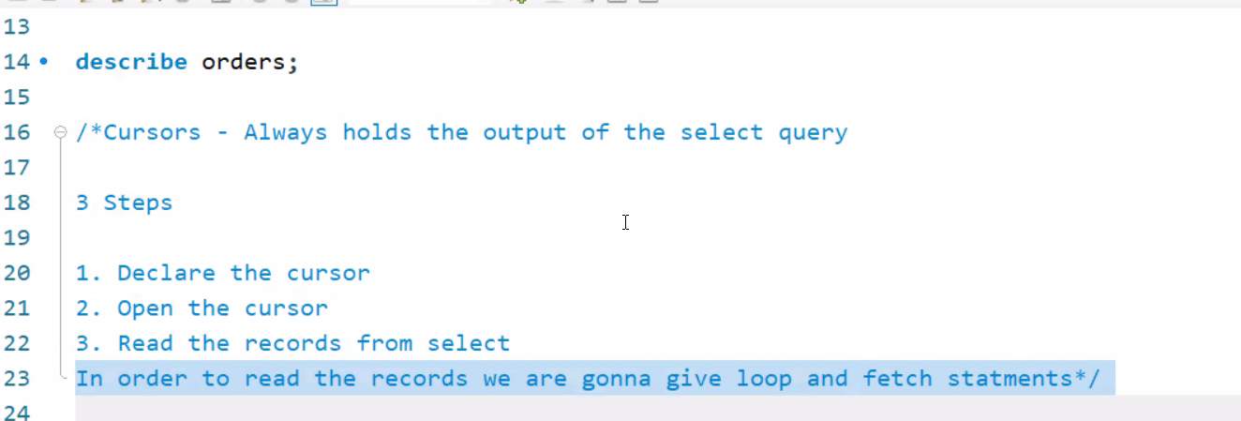

Hold the output the output

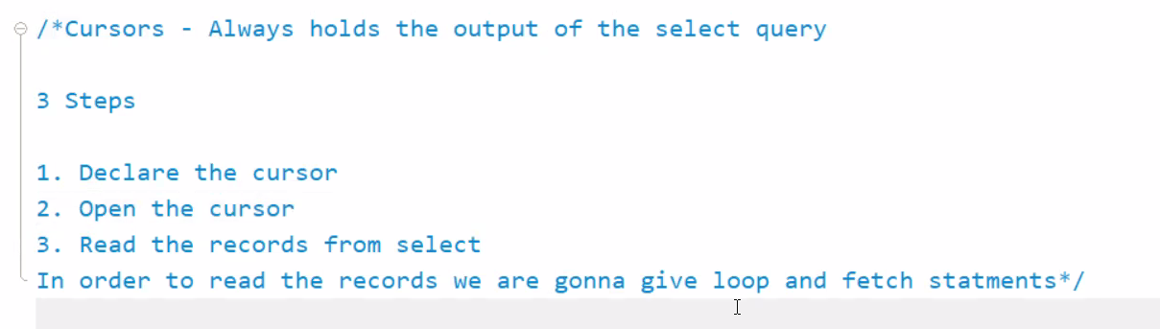

Cursor is a pointer used to read each and every record of a particular table .

Not found Error is the generic type of Error inside the Cursor

What is the input of data on Cursor

Cursor will have select statement

Any select statement can be given as Input of statement

Stored procedure : Step by step instruction , Automated activity

Procedure are may or May not value

Function is will give a scalar value

All Views are tables and these are stored in database ;

A small version of the table

Views are stored in Database

ACID : Atomicity consistence isolation Durability;

Durability : Backup